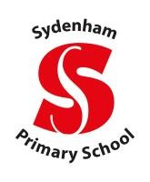

**Leamington Federation**

**Sydenham Primary School and Lighthorne Heath**

**Relationships, Sex and Health Education Policy**

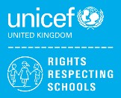

**UN convention on the Rights of the Child.**

As part of the Education Act 2002, all schools must provide a balanced and broad-based curriculum which promotes the spiritual, moral, cultural, mental and physical development of pupils at the school and of society, whilst also preparing pupils for the opportunities, responsibilities and experiences of later life.This policy reflects the principles of equality, dignity, respect, non-discrimination and participation. At Sydenham and Lighthorne Heath Primary Schools, we recognise achievement in putting the UN Convention on the Rights of the Child at the heart of our practice to improve well-being and help all children realise their potential. Children’s rights are learned, taught, practiced, respected, protected and promoted in our schools.

# Aims

* To provide a framework in which sensitive discussions can take place
* To enable children to understand and respect their bodies and be able to cope with the changes puberty brings.
* To help children develop healthy relationships, appropriate to their age and development.
* To support children to have positive self-esteem and body image.
* To empower children to be safe and safeguarded.
* To support children’s physical, emotional and moral development.

# Statutory requirements

As a maintained primary school we must provide relationships education to all pupils as per section 34 of the Children and Social Work Act 2017. We are not required to provide sex education but we do need to teach the elements of sex education contained in the science curriculum (Appendix 1).

**Introduction**

This policy covers our schools’ approach to Relationship and Sex education, not only in lessons but through the attitude of our staff and students alike, our ethos and approach and commitment to equality both within and outside of the classroom It was produced in consultation with our staff, board of governors, and most importantly with our pupils and parents/carers. It will be reviewed every year to ensure that it reflects the attitudes and beliefs of the school population and remains up to date with both current guidance from Government and the DfE but also remains relevant to the experiences of our pupils.

To ensure its use, this policy will be available for staff to review through allocated staff meetings, and to parents/carers through our school website.

We acknowledge that in order for children to embrace the challenges of creating a happy and successful adult life, pupils need knowledge that will enable them to make informed decisions about their wellbeing, health and relationships and to build their self-efficacy. We understand that high quality, evidence-based and age-appropriate teaching of these subjects can help prepare pupils to develop resilience, and to know how and when to ask for help.

We recognise that we have a responsibility under the Equality Act 2010 to ensure the best for all pupils irrespective of disability, educational needs, race, nationality, ethnic or national origin, sex, gender identity, pregnancy and maternity, religion, sexual orientation or whether they are children who are looked after. We will make every attempt to be appropriately sensitive; equally it is essential that young people still have access to the learning they need to stay safe, healthy and understand their rights as individuals. This must include clear, impartial scientific and factual information. Furthermore, all teaching should reflect the law as it applies to relationships, marriage, adoption and care.

**Defining Comprehensive Relationship Education at Primary School**

The Department for Education defines relationships education as, *teaching the fundamental building blocks and characteristics of positive relationships, with particular reference to friendships, family relationships and relationships with other peers and adults.* We believe comprehensive relationship education is about helping children understand and make sense of the world they are growing up in; to recognise the differences and similarities between their peers and their families; to understand the fact that every human being is unique and has the right to be respected; that there are many different family structures and all children have the right to feel safe.

Comprehensive relationship education has been shown to help keep children safe by allowing them to understand appropriate and inappropriate touching, to realise that their body is fantastic and belongs to them. It is about building the foundations of an understanding of consent and personal boundaries; in that no one has the right to touch you in a way you don’t like but also the difference between public and private behaviours.

It is important for children to know the names and functions of their body and to be reassured it is natural to be curious about them. Indeed, by teaching children the correct terms for their private parts, children are proven to be safer from abuse.

In addition, we believe comprehensive relationship education helps children to develop their vocabulary and emotional literacy to enable them to talk about and manage their feelings. It helps children build their own support networks and the confidence to ask for help when they feel unsafe. This is a required element of the Health Education Guidance.

**Defining Sex Education at Primary School**

Although the *Relationships Education, Relationship & Sex Education and Health Education (England) Regulations 2019* made Relationship Education compulsory in all primary schools, Sex Education is currently **not** compulsory. However, the Department for Education continues to recommend that all primary schools should have a sex education programme tailored to the age and maturity of the pupils.

We recognise that some parents/carers may be uncomfortable with the thought of their children receiving sex education in primary school. Equally, we recognise it is completely natural for children to have questions about sex, their bodies, and to be curious about where they came from. In the age of information where children in primary school have access to the internet through mobile technology, we believe it is better that children receive **age appropriate** answers from us than it being left to their peers or the internet.

In our school, sex education is an opportunity to answer children’s questions about where they came from; an opportunity to explore their own stories and to be clear about how a baby is conceived and formed as set out in the national curriculum for science. Furthermore, it should ensure that all children are prepared for both the physical and emotional changes of puberty including menstruation.

We believe it is the duty of our school to give our young people the learning that will enable them to live safe, fulfilled and healthy lives. This includes ensuring that they have the skills to keep themselves safe from harm and develop positive and healthy relationships, free from exploitation pressure or abuse.

**Roles and Responsibilities**

**The Governing Body**

The governing body ratifies and approves this policy.

**The Headteacher**

The Headteacher is responsible for ensuring that RSHE is taught consistently across the school and for managing requests to withdraw pupils from non-statutory/non-science components of RSHE.

**Staff**

Class teachers are responsible for:

* Delivering RSHE in a purposeful and sensitive way.
* Modelling positive attitudes to RSHE.
* Monitoring progress.
* Responding to the needs of individual pupils.
* Responding appropriately to pupils whose parents wish them to be withdrawn from the non-statutory/non science components of RSHE.

Class teachers do not have the right to opt out of teaching RSHE. Staff who have concerns about teaching RSHE are encouraged to discuss this with the Subject Leader and Headteacher.

**Pupils**

Pupils are expected to engage fully in RSHE and, when discussing issues related to RSHE, treat others with respect and sensitivity.

**Subject Content**

In school we meet the learning objectives as set out in the *Relationships Education, Relationship & Sex Education and Health Education (England) Regulations 2019* for primary schools with a whole school approach. Across all year groups, teachers deliver both the *Protective Behaviours: The Taking Care Scheme* as recommended by Warwickshire’s Safeguarding Children’s board as well as The PSHE Association’s Programme of Study. Both are based on a spiral curriculum beginning in Reception, building on key messages through to Year Six.

**Protective Behaviours**

Protective Behaviours is a practical and down to earth approach to personal safety. It is a process which encourages self-empowerment and brings with it the skills to avoid being victimised. This is achieved by helping children recognise and trust their intuitive feelings (Early Warning Signs/EWS) and to develop strategies for self-protection. The Protective Behaviours process encourages an adventurous approach to life which satisfies the need for fun and excitement without violence and fear. The programme has two themes which run throughout the sessions:

**Theme 1:** We all have the right to feel safe all the time.

**Theme 2:** We can talk with someone about anything, even if it feels awful or small.

Protective Behaviours is delivered across the entire school from Reception to Year Six in the first half of the autumn term. There are four lessons in each year group. Lessons are delivered over one week, although the lessons are revisited throughout the school year.

**An overview of the Programme Content:**

For more details please see the school’s Protective Behaviour Manuals for each year group. These can be made available on request. For further information, parents/carers can visit https://www.protectivebehaviours.org.

|  |  |  |  |  |
| --- | --- | --- | --- | --- |
| **Protective Behaviours – Taking Care Programme** | | | | |
| **Reception** | Feelings | Body Awareness | EWS / Scary Body Feelings | Telling & Secrets |
| **Year 1** | Feelings | Unsafe Feelings and Body Awareness | Body Privacy & Secrets | Telling & Networks |
| **Year 2** | Feelings, Rights & Responsibilities | Unsafe Feelings, Problem Solving | Body Awareness & Personal Space | Networks & Using Them |
| **Year 3** | Feelings, Rights & Responsibilities | Unsafe Feelings | Body Awareness & Telling | Networks & Using Them |
| **Year 4** | Rights & Responsibilities;  Feelings | Safe & Unsafe Feelings | Exploring Secrets | Networks & Using Them |
| **Year 5** | Rights & Responsibilities;  Feelings | Safe Feelings; Fun to Feel | Secrets & Networks | Using Networks |
| **Year 6** | Rights and Responsibilities; Feelings | Safe Feelings; Fun to Feel Scared; EWS | Secrets & Networks | Using Networks |

**Jigsaw Programme of Study**

PSHE lessons cover all statutory requirements and are organised around three core themes:

1. Health and Wellbeing
2. Relationships
3. Living in the Wider World

Teaching builds according to the age and needs of the pupils throughout the primary phase with suggested developmentally appropriate learning objectives suggested. Units of work are structured around an overarching question for each term or half term. These begin in Key Stage 1 as ‘What? And ‘Who?’’ questions and build throughout Key Stage 2 into ‘How?’ and ‘Why?’ questions.

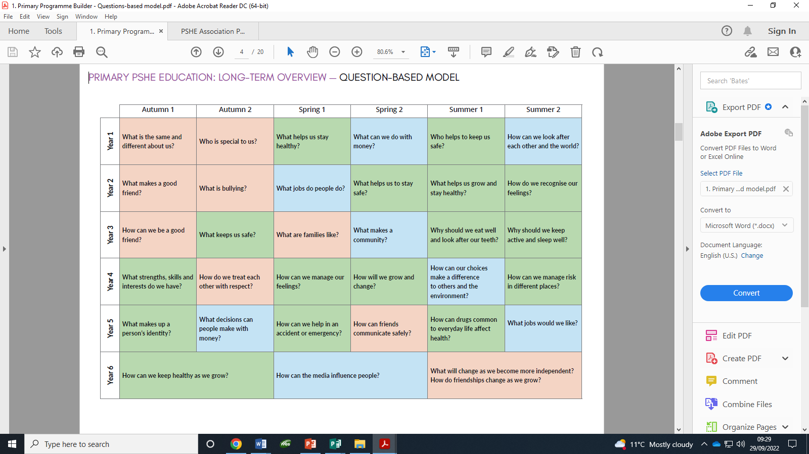

**Menstruation Wellbeing**

Puberty is occurring earlier than ever before, and it is now not uncommon for children to start their periods whilst in primary school even in Year Four. For this reason we deliver puberty lessons to all children in Year Four, Five and Six. As part of these lessons all children will be told about menstruation and there will be discussion of what periods are, explanation of other symptoms associated with periods, how they can be managed hygienically, and sensitively. During lessons where puberty and menstruation are discussed, we will take the opportunity to highlight the location of sanitary bins available in school, and how these are to be used.

In school we have menstruation kits available in Year Four, Five and Six classrooms which contain sanitary products, spare underwear and plastic bags to wrap up underwear should there have been any accidents. Children will be made aware in September as they begin in these year groups of where these are kept and how they can be accessed through designated members of staff, including lunchtime supervisors.

We do not separate our lessons into girls and boys for any part of the programme, including lessons around puberty. We believe it is important for both girls and boys to learn about the human body, its changes and experiences. By keeping children together in mixed groups, children will learn to talk openly without embarrassment in front of each other and we can foster better understanding, break down gender stereotypes and build positive relationships and respect for each other, regardless of gender. This ensures that any non-binary or transgender children are included without feeling vulnerable.

**Answering Children’s Questions**

Teachers will answer questions openly, honestly, scientifically and factually without reference to their own personal beliefs. Teachers will not be expected to answer personal questions about themselves or to ask direct personal questions of their students that could make either parties vulnerable.

**Parents and parental rights to withdraw**

We believe that successful teaching around RSHE can only take place when parents and school work in partnership to ensure children are equipped with the knowledge and understanding to enable them to grow up in a safe and happy environment to form healthy relationships.

Parents and carers do not have the right to withdraw their children from Relationships Education, Health Education or lessons included in the Science curriculum (Appendix 1.) They do, however, have the right to withdraw their children from non-statutory/non-science components of Sex Education within RSHE. If parents/carers do decide to withdraw their child, they should inform the Head Teacher who must find alternative provision for the child to engage in during the lesson.

We endeavour to be transparent and give parents and carers information about all the programmes and lessons we deliver around RSHE as we recognise it can be a sensitive subject for some families for a number of reasons. Parents and carers knowing about the content of the lessons means they can carry on the conversations at home and have an opportunity to talk to their children about their own families, beliefs and values.

**Safeguarding Children**

When teaching any sensitive topic, such as RSHE which deals with family life, safe and appropriate touching, personal body parts and healthy relationships, we recognise the potential to uncover incidents of abuse through children’s disclosures. All members of staff who deliver any of our Relationship or Sex Education Programme, have statutory training around safeguarding children and are all aware of our school’s safeguarding policy and procedures in the case of a disclosure or suspicion of a safeguarding concern.

We recognise that for children who may be vulnerable due to past or present abuse or changes in family situations, this type of work may need to be adapted or additional support be offered. Our Relationship and Sex Education programme is considered a protective factor in preventing further abuse; to help children make sense of their experiences and is essential to help them develop skills and resilience to keep them safe in future.

# Monitoring arrangements

The delivery of RSHE is monitored by the Executive Head Teacher and Associate Head Teachers through planning scrutinies, learning walks and monitoring of lessons delivered. Any feedback from teachers, parents/carers and pupils will be considered when monitoring the effectiveness of this policy. Pupils’ development in RSHE is monitored by class teachers as part of our internal assessment systems.

**This policy was ratified:** September 2024

**And will be reviewed:** September 2025

**Signed by the Executive Head Teacher:** 

**Chair of Governors:** Richard Butler

**Appendix 1**: Summary of science programme of study with specific reference to the human body and reproduction

Year 1: Identify, name, draw and label the basic parts of the human body and say which part of the body is associated with each sense.

Year 2: Notice that animals, including humans, have offspring which grow into adults.

Year 5: Describe the life process of reproduction in some plants and animals; describe the changes as humans develop to old age, including puberty.

**Appendix 2:** Definition of ‘consent’ as taught within the context of lessons

No one should ever touch you without your permission or consent. You have the right to decide who you allow into your personal space and you should always respect other people’s right and wishes too.

**Appendix 3:** Content laid out in DfE Relationships Guidance

